



Creating Python Variables and Assigning values to Variables
LAB MANUAL

Disclaimer: The content is curated from online/offline resources and used for educational purpose only
Creating Python Variables and Assigning values to Variables
Objective:
To understand how to create variables in Python and assign values to them.
Problem Statement:
Variables are fundamental to programming as they allow you to store and manipulate data. This lab manual demonstrates how to create variables in Python and assign values to them, along with an overview of different data types.

Procedure:
Task 1: Creating Variables
Task 2: Assigning Values
Task 3: Displaying Variable Values

Code: Valid variables

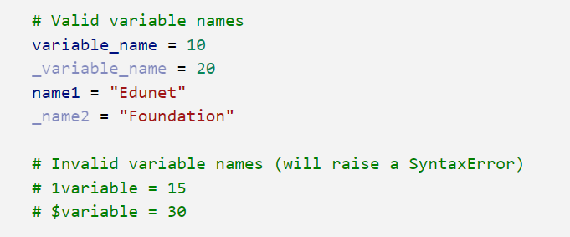

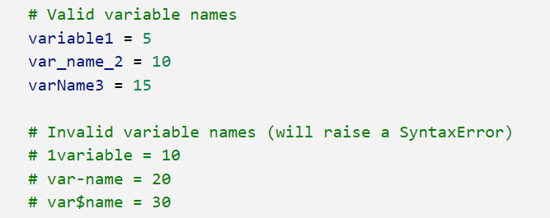

Code: Case-Sensitive variables
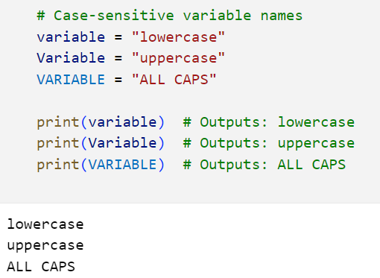

Code: Special character variable

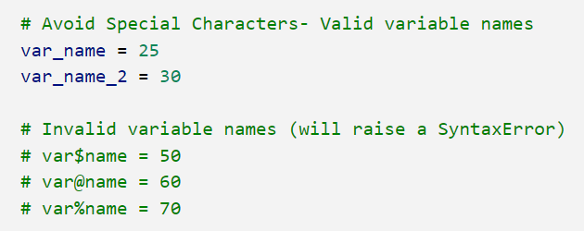

Code: Descriptive variable
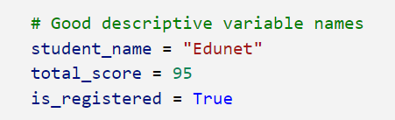

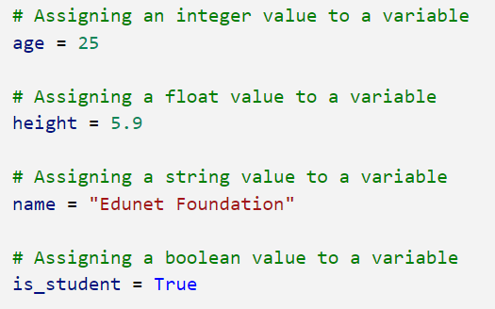

Code: Multiple assignment of variables
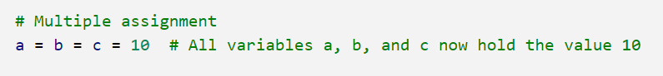

Code: Multiple value assignment
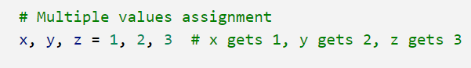

Output:
Successfully added all valid variable and assigned values to variables

